Experiment 4 — Supervised Learning
Name : Prem Vijay Hanchate
Roll no : 68 Class : TE/IT

Aim
To perform correlation analysis on the Aadhar Enrollment dataset by computing and visualizing the relationships between enrollment variables across age groups using histograms, a Pearson correlation heatmap, and scatter plots, in order to identify the strength and direction of linear relationships among numeric features.

Theory
1. Feature Engineering: Raw datasets often do not contain all the variables needed for analysis. Feature engineering is the process of creating new meaningful columns from existing ones. In this experiment, a new column Total_Enrollment is derived by summing the three age-group columns — age_0_5, age_5_17, and age_18_greater — with missing values replaced by 0 using fillna(0) before summation. This gives a single unified enrollment count per record, which is useful for holistic analysis.
2. Distribution Analysis — Histograms: A histogram divides a continuous variable into equal-width intervals (bins) and plots the frequency of observations falling into each bin. It reveals:
- Central tendency — Where most values are concentrated (mean and median lines).
- Spread — How wide or narrow the distribution is.
- Skewness — Whether the distribution is symmetric, left-skewed (tail on left), or right-skewed (tail on right).
For enrollment data, histograms help identify whether most districts have low enrollment counts with a few outliers at the high end (right-skewed), which is common in demographic datasets.
3. Correlation Analysis — Pearson Coefficient: The Pearson Correlation Coefficient (r) measures the strength and direction of the linear relationship between two numeric variables. Its value ranges from −1 to +1:
Value | Interpretation
r = +1 | Perfect positive linear relationship
0 < r < 1 | Positive relationship (as one increases, so does the other)
r = 0 | No linear relationship
−1 < r < 0 | Negative relationship
r = −1 | Perfect negative linear relationship
The correlation matrix is computed using df.corr(), which calculates pairwise Pearson coefficients for all numeric columns. Strong correlations between age groups would indicate that districts with high enrollment in one group tend to have high enrollment in others as well.
4. Correlation Heatmap: A heatmap is a 2D grid visualization where each cell's color encodes the magnitude and direction of the correlation coefficient between two variables. Darker or brighter colors represent stronger correlations. A heatmap makes it easy to quickly scan and compare all pairwise correlations at once, especially in datasets with many numeric features. Annotations inside each cell display the exact correlation value for precision.
5. Scatter Plots and Trend Lines: A scatter plot displays individual data points on a 2D plane, with one variable on the X-axis and another on the Y-axis. Each point represents one record. Scatter plots are used to:
- Visually confirm correlations — Points forming a clear upward or downward diagonal pattern indicate a linear relationship.
- Detect outliers — Points far from the main cluster stand out clearly.
- Identify non-linear behavior — If points form a curve rather than a line, a linear model may not be appropriate.
A trend line (regression line) is overlaid on each scatter plot to indicate the overall direction and slope of the relationship. In pairwise scatter plots across age_0_5, age_5_17, age_18_greater, and Total_Enrollment, the trend lines help visualize how strongly each pair of variables moves together.
6. Interpreting the Three Outputs Together: The three visualizations complement each other:
- Histograms reveal the individual distribution of each variable — skewness, concentration, and spread.
- Heatmap provides a quick numerical summary of all pairwise correlations in one view.
- Scatter plots visually confirm what the heatmap reports and expose outliers or anomalies that correlation numbers alone cannot reveal.
Together, they form a complete picture of how enrollment variables are distributed and how they relate to one another.

Execution
The following operations were performed step-by-step on the Aadhar Enrollment dataset:
Step 1 — Load and Inspect Data: The Excel file Sample_Aadhar_Enrollment_Dataset.xlsx was loaded into a Pandas DataFrame. Basic inspection was performed using shape, info(), head(), and describe() to confirm the dataset structure — 99 rows, 7 columns — and to identify data types and null counts.
Step 2 — Feature Engineering: A new column Total_Enrollment was created by summing age_0_5, age_5_17, and age_18_greater after filling missing values with 0. This column represents the total number of Aadhar enrollments per record regardless of age group.
Step 3 — Histogram Plotting: Histograms were plotted for each age group column and for Total_Enrollment. Mean and median lines were overlaid on each histogram to indicate central tendency. The plots were saved as aadhar_enrollment_histograms.png. Each histogram was followed by a printed interpretation summary describing the skewness and concentration of enrollment values.
Step 4 — Correlation Matrix and Heatmap: The Pearson correlation matrix was computed using df.corr() on the numeric columns. A heatmap was generated using seaborn.heatmap() with annotations showing the exact correlation value in each cell. The heatmap was saved as correlation_heatmap.png. A printed interpretation summary followed, describing which pairs of variables had strong, moderate, or weak correlations.
Step 5 — Scatter Plots with Trend Lines: Pairwise scatter plots were generated for all combinations of age_0_5, age_5_17, age_18_greater, and Total_Enrollment. A linear trend line was fitted and overlaid on each scatter plot using numpy.polyfit() or seaborn.regplot(). The plots were saved as aadhar_enrollment_scatter_plots.png. A printed interpretation summary followed, describing the direction of each relationship and highlighting any visible outliers.
Summary of Outputs Generated:
Output File | Description
aadhar_enrollment_histograms.png | Age-wise and total enrollment frequency distributions
correlation_heatmap.png | Pearson correlation matrix visualized as a colored heatmap
aadhar_enrollment_scatter_plots.png | Pairwise scatter plots with trend lines showing variable relationships

Output

  - What It Does with the Aadhaar Dataset
The program creates 6 histograms to analyze Aadhaar enrollment data for different age groups:
- Age 0–5 Histogram – Shows enrollment distribution for children.
- Age 5–17 Histogram – Shows school-age enrollments, which are the highest.
- Age 18+ Histogram – Displays adult enrollment distribution.
- Total Enrollment Histogram – Shows overall enrollment patterns.
- Overlapping Histogram – Compares all age groups together.
- Cumulative Histogram – Shows overall enrollment growth and percentiles.
Key Insights
- Most districts have lower enrollments, while a few have very high enrollments.
- The data is right-skewed because the mean is higher than the median.
- The 5–17 age group has the highest enrollment numbers.
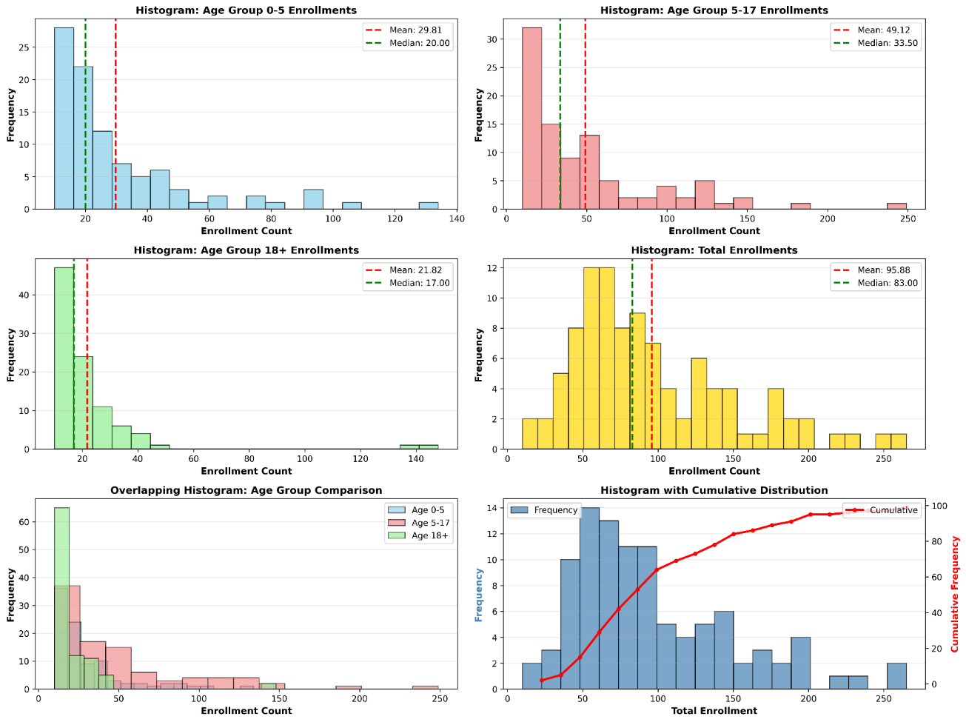

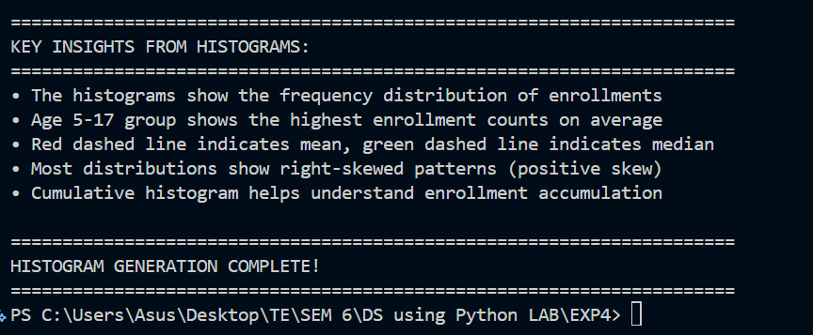
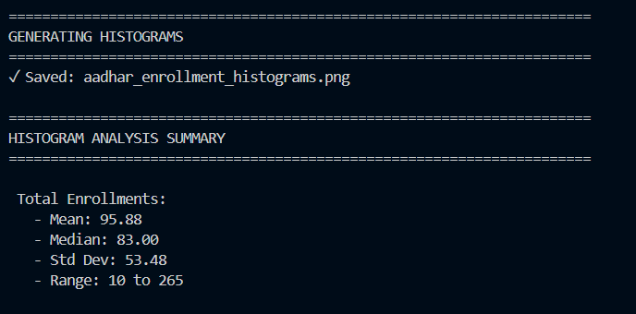

  - What It Does with the Aadhaar Dataset
The heatmap analyzes the correlation between:
- Pincode
- Age 0–5
- Age 5–17
- Age 18+
- Total Enrollment
Color Meaning
- 🔴 Red → Strong positive correlation (both increase together)
- ⚪ White → Weak or no correlation
- 🔵 Blue → Negative correlation (one increases, other decreases)
Key Findings
- Age 5–17 ↔ Total Enrollment = 0.810
  - Strongest impact on total enrollments.
- Age 0–5 ↔ Total Enrollment = 0.560
  - Moderate contribution to total enrollments.
- Pincode ↔ Age 0–5 = -0.303
  - Weak negative relationship.
- Age 0–5 ↔ Age 18+ = -0.090
  - Almost no relationship.
Practical Use
The heatmap helps identify:
- Which age group contributes most to enrollments
- Relationships between age groups
- Geographic trends using pincodes
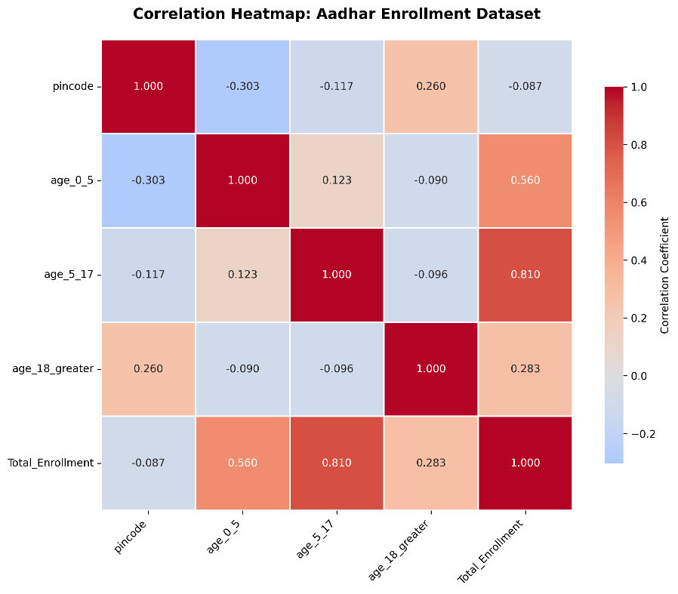
- Important variables for predictions and analysis
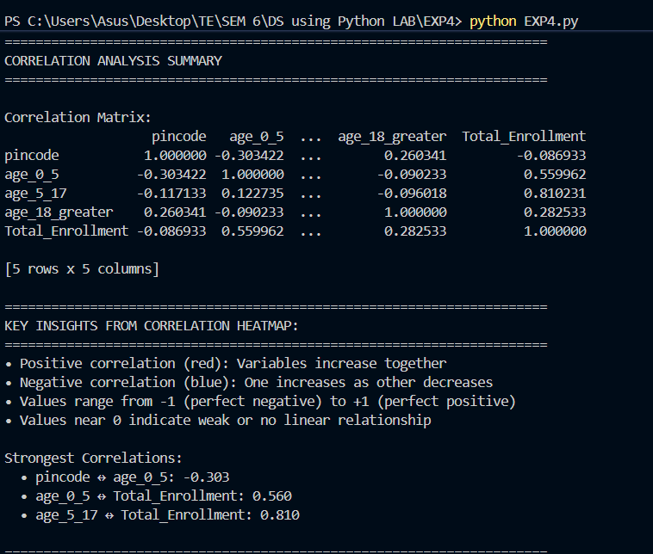

  - The analysis uses 6 scatter plots to study relationships between enrollment age groups.
- Age 0–5 vs Age 5–17
  - Compares child and school-age enrollments.
  - Shows a weak positive relationship (0.123).
- Age 0–5 vs Age 18+
  - Compares child and adult enrollments.
  - Very weak negative relationship (-0.090).
- Age 5–17 vs Age 18+
  - Compares school-age and adult enrollments.
  - Weak negative relationship (-0.096).
- Age Groups vs Total Enrollment
  - Compares all age groups with total enrollments using different colors.
  - Age 5–17 has the strongest impact on total enrollments (0.810).
- Color Gradient Scatter Plot
  - Shows Age 5–17 vs Total Enrollment with Age 0–5 shown using color intensity.
  - Helps visualize relationships between three variables together.
- Pincode vs Total Enrollment
  - Checks whether location affects enrollments.
  - Very weak relationship (-0.087), meaning pincode has little effect.
Key Insight
The 5–17 age group contributes the most to total Aadhaar enrollments, while other variables show weak relationships.
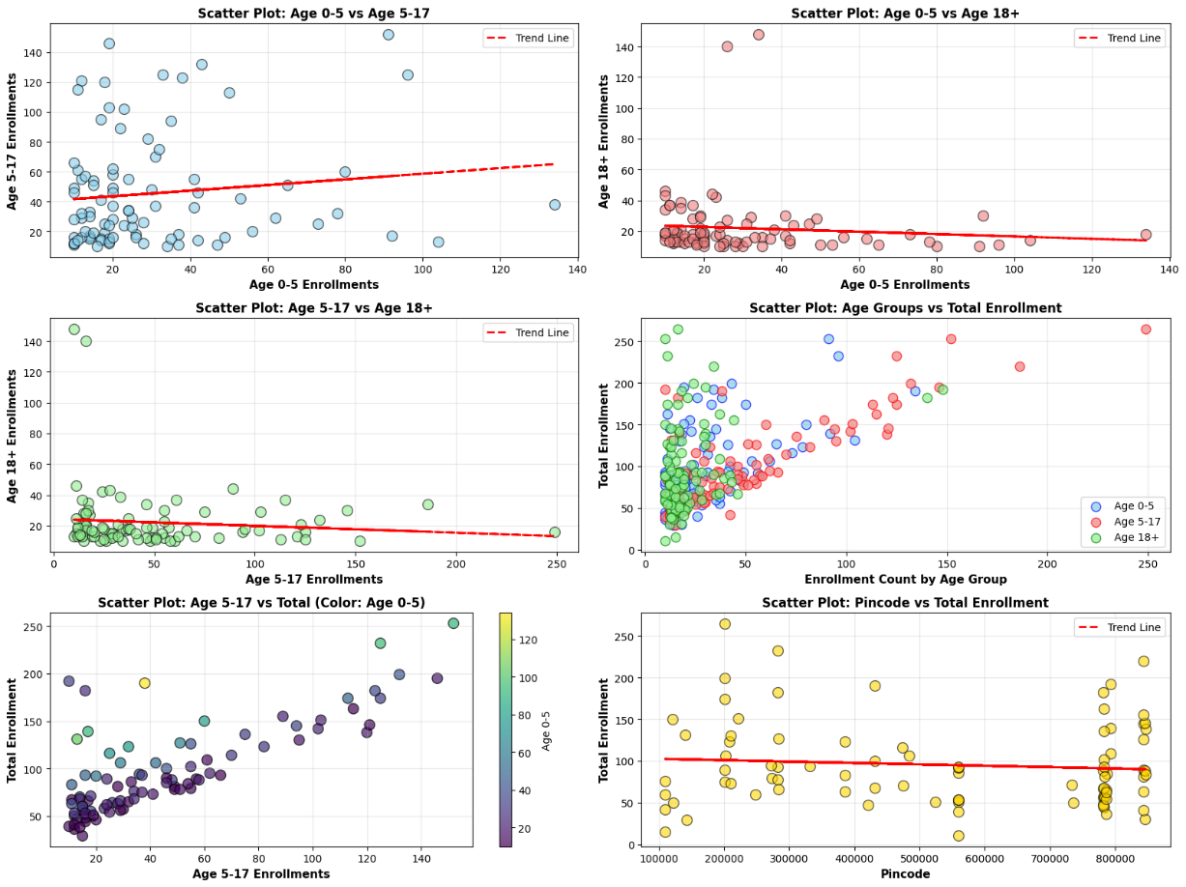

Conclusion
In this experiment, correlation and distribution analysis was performed on the Aadhaar Enrollment dataset. A new feature, Total Enrollment, was created by adding all three age-group enrollments. Histograms showed the distribution and skewness of enrollment data, while the correlation heatmap identified relationships between variables. Scatter plots with trend lines helped visualize these relationships and detect outliers.

